**4 Spray Painting Companies To Transform Your Car Into The Design Of Your Dreams**

Giving your car a new coat of paint is more complicated than simply purchasing a can of paint, rolling up your sleeves, and getting down and dirty with a paintbrush. Aside from the application of multiple layers of colour to your car to achieve a high-quality finish, you'll also need specialised tools for panel beating, sanding, spraying, and polishing. Remember that professional skills and experience are required to perform a quality spray paint job. [Car spray paint](https://goldautoworks.com.sg/car-spray-paint-company-singapore/) can be an expensive service. But when you consider the amount of work involved in the process, it is worth the money.

Here are some highly-rated and successful car spray paint companies for you to consider if you find yourself in need of their services.

**Gold Autoworks**

Gold Autoworks is located in the western part of Singapore - namely, the 48 Toh Guan Road East area. For the drivers, you will know that there are many [car workshop](https://goldautoworks.com.sg/)s and [car garage](https://goldautoworks.com.sg/car-repair/)s located in this area. How do you then choose a car mechanic to help you with your car spray painting service?

Let us introduce you to [Gold Autoworks](https://goldautoworks.com.sg/about-us/). Gold Autoworks has been in the market for close to a decade. In the span of these years, they have accumulated more than 120 Google Reviews. Interestingly, a majority of these reviews are either 4 stars or 5 stars review!

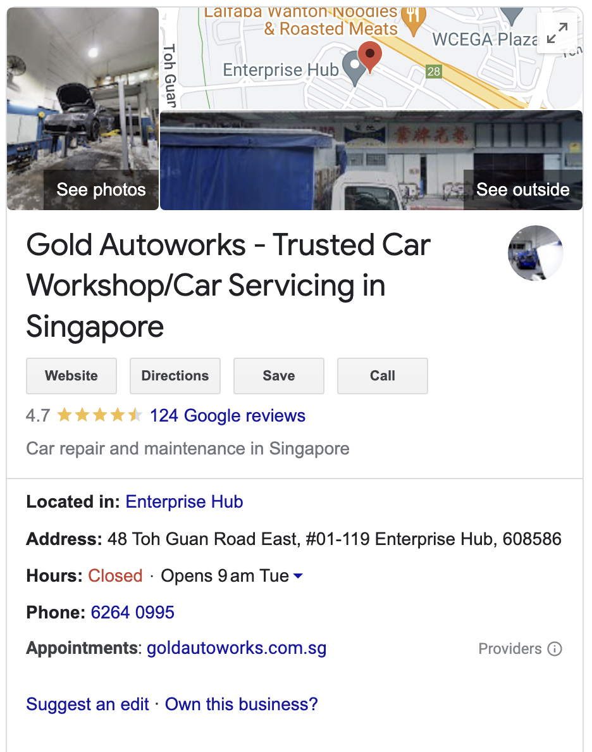

If you wish to contact Gold Autoworks, here are some information to share with you.

| **Gold Autoworks Contact Details** | |
| --- | --- |
| Website Address | <https://goldautoworks.com.sg/> |
| Physical Location | 48 Toh Guan Road East, #01-119 Enterprise Hub, Singapore 608586 |
| Telephone Number | 6264 0995 |
| Email Address | [admin@goldautoworks.com.sg](mailto:admin@goldautoworks.com.sg) |
| Mobile Number | 8199 9149 |

**Revol Carz**

Revol Carz, founded in 2003, has evolved from a two-people operation as a mobile car groomer to a multi-disciplinary service leader in Professional Car Care. Revol Carz has received numerous awards like the "SGCarMart Star Merchant" award for eight consecutive years.

They also have many accolades for entrepreneurship and innovation. They have worked on over 6000 cars with accident damage, restoring them to their original "as good as new" condition using the latest in-house spray painting techniques and years of experience. Their in-house repair specialists are skilled in paint respraying with 100% colour-matching accuracy using **Spies Hecker Paint Systems** from Europe. There is no colour mismatching or sloppy work. Whether you need a partial paint repair or a complete car body color change, their Paint specialists and Color professionals can help!

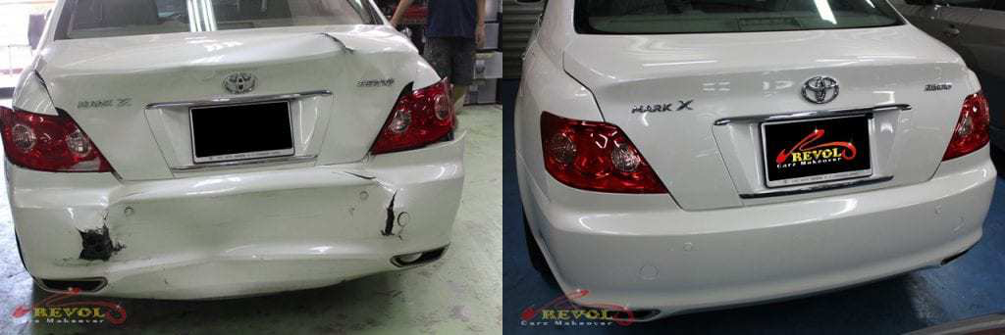

**Spray Painting Features:**

* Pro-Refinishers

Their paint specialists have a combined paint experience of over 20 years. Expect them to produce work of the highest caliber. They are proud of the quality they produce and are perfectionists.

* 100% Color-Matching Paint Accuracy

There will be no mismatched colours on different panels – guaranteed. Their advanced paint systems, combined with the years of experience of their in-house paint specialists, ensure that colour calibration is perfect every time.

* In-house wholly owned and managed

They own and operate their own car spray paint shops. They do not outsource the work to others. It means that the onus is on them to ensure that everything is to their exacting standards.

**Prices For Spray Painting**

Their respray and damage repair rates offer the best value for money for first-rate service.

| **Type** | **Price ($)** |
| --- | --- |
| Panel beating | > 50 |
| Spray painting on individual panels | > 200 |
| Complete car spray painting | > 1300 |

**Dent Repair Without Paint**

| **Type** | **Price ($)** |
| --- | --- |
| 1st dent | 25 |
| 2nd dent | 15 |
| Subsequent dents | 10 per dent |
| Difficult to reach or larger dents | Quote based on evaluation |

**Outlets:**

1. Blk 42 Toh Guan Road East #01-75 Enterprise Hub Singapore 608583
2. 10 Ang Mo Kio Industrial Park 2A #01-12 AMK Autopoint Singapore 568047

**Ngai Hong Spray Painting**

They have been in business since 1974 and have over 40 years of spray painting experience. They are confident that you will be pleased with their ongoing service and assistance to you. Every job is a work of art to them. They are aware that you adore your vehicle and that it is an essential part of your life! As a result, every car that enters their workshop represents an opportunity to demonstrate its true potential.

Whether it's the laborious process of panel beating, applying putty, spraying on a uniform coat of paint, or polishing and waxing, each step is as important as the next. Their works of art are now yours to display and own. Yes, it's entirely yours. They are committed to providing you with an exceptional experience by providing professional service and ensuring complete customer satisfaction.

Ngai Hong Spray Painting has been in business for two generations. Since their origin in 1974 as Ngai Hong Spray Painting Knocking & Panel Beating, they have gradually built a customer base based on trust and quality performance. They changed their company's name to its current one in 2005 and have acquired many products over the years. These products have improved the quality of their work and service. They are adamant about constantly improving their products to provide the best service possible to you. Quality assurance has been their guiding principle throughout their successful 40-year career in Singapore's automotive industry. They take pride in assisting you in any way they can as long as cars are involved.

**Spray painting**

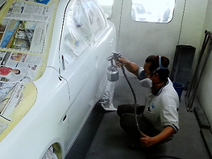

Spray painting is essential in defining who they are. It may appear to be a simple task, but there is more to perfecting the craft than meets the eye. With over 40 years of experience, they guarantee the highest quality performance and materials available to bring out the best in your vehicle. Their spray painting services are available for all cars, with a wide range of color bases available, including glossy and matt finishes. Finishing with polish, it enhances the color and shine of the car, bringing a smile to your face.

**Services provided:**

* Spray painting
* Waxing and polishing
* Insurance claim for a car accident
* Others

**Prices for spray painting**

Varies for different cars

**Outlet:**

160 Sin Ming Drive #06-08 Sin Ming AutoCity Singapore 575722

**Green Star Spray Paint**

Green Star Spray Paint (GSSP) has been in operation since 1970, and Mr. Roger Tan and Ms. Janice Tan, a husband and wife team, are currently managing the company. GSSP is a well-known local business that provides a wide range of services such as panel beating, body kit assembly, custom body kits, spray painting projects, [car spray painting](https://goldautoworks.com.sg/car-spray-paint-singapore/), and vehicle insurance claims. And, to meet the growing demands of their valued customers, GSSP expanded their business to repair and services to provide more quality and value-added services, and is now known as "Green Star Spray Painting Garage Pte Ltd."

**Services provided:**

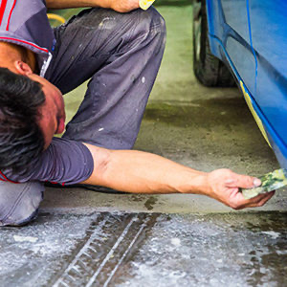

* Spray painting a vehicle

Spies Hecker Paint has been their preferred paint for vehicle spray painting jobs. They have a large selection of colours that match your vehicle's color profile or your chosen colour change.

* Renewal of vehicle insurance
* Welding on panels
* Insurance claim for a vehicle
* Projects for spray painting

With their specialised spray painting knowledge and experience, they can take on ad hoc spray painting projects to meet the needs of their customers.

* Assembly of the body kit
* Car maintenance
* Wheel repair and computerised alignment

**Prices for spray painting**

Varies for different cars

**Outlet:**

Block 3011 Bedok North Avenue 4 #01-2004/2006 Bedok Industrial Park E Singapore 489977

If you are looking for a [car spray paint company](https://goldautoworks.com.sg/), look no further! These three companies will do a good job for you.